Ryanair & EasyJet Budget Airline:



**A Case Analysis**

**Donald Paul, Daisley, Bernard;Brady, Rosemarie;Ferary, Reynold;(March 2018)**

Table of Contents

Introduction 1

Overview of Status 2

a. Organizations’ Purpose 2

b. Airline Operation 2

c. Business Environment 2

* + 1. *Internal*  2
    2. *External (PESTEL, SWOT & Porter’s Five Forces)* 2-4  *d. Strategic Capabilities* 5

1. *Old* 5
2. *New* 5
3. *Financial Competence* 6-8
4. *Marketing Competence* 8-9

*e. Environmental**Challenges* 10

**Forecast of PESTEL Analysis and Porter’s Five Forces** 10

* 1. *Organization’s Strategic Success and Failures* 10
  2. *Key Factors of Change* 10

**Recommendations** 11

**Conclusion** 11

**References** 12

**Appendix** 13

**1. Introduction**

Ryanair and easyJet are Irish and British low-cost carrier airlines (Budget Airlines) respectively, which operates domestic and international flights out of the Europe. They are rated the two top largest companies in the low-cost airline industry. Ryanair being the chief competitor with its headquarters in Swords, Dublin, serves 211 destinations in 34 countries; is followed by easyJet with its headquarters in London’s Luton Airport, which serves 124 destinations in over 30 countries (Wikipedia, 2018). (See Figures 1 and 2 for comparable information on both airlines.)

Both Ryanair and easyJet have managed to strategically beat both internal and external odds to successfully develop and grow exponentially in the European airline market. This they have done by consistently offering cheap fares, a critical success factor for them, using a number of key business strategies to stay innovative in their current blue ocean market in spite of key problems that they face in the business.

Over the years these two strategic groups as low budget airlines, have also employed aggressive expansions in airplane fleet size; airline acquisitions and increased airline share capitals as part of their key business strategies in targeting their “European friends”.

It is important to note that crucial to the development of Budget Airlines out of the existing traditional Red Ocean Market airline industry, the following historical factors greatly contributed to the Blue Ocean Market that Ryanair and easyJet now enjoy:

* Cost for travel was very high
* Fuel cost increase
* Economic downturn – Gulf War recession in early 1990’s
* Bankruptcy in the Industry – e.g. Major airlines such as Pan American and TWA
* Airline travel virtually stalled
* Deregulation of the airline industry in Europe – “Open Skies Agreements” (1990’s)
* Competition increased with building of new airports
* Target group of travelers was Business Travelers - decreased with the economic downturn.
* Increased travel costs due to 9/11

As such, Ryanair and easyJet airlines have grown at the expense of traditional national airlines as they capitalize on targeting tourists and shift towards shorter routes.

Both these two airlines share strong external competition from traditional airlines such as Aer Lingus, Lufthansa, Air France and British Airways as well as the number one budget airline in the world, Norwegian Airline.

For this case analysis, our first need is identifying strategic issues and key problems that management would need to address. After which, an analysis and evaluation will follow to determine their effectiveness and suggest recommendation(s) accordingly.

**2. Overview of Status**

1. ***Organization Purpose***

Considering their need to maintain their status as the leading budget airlines operating out of Europe, Ryanair and easyJet strive to maintain their low fares and strong customer base as they continue to create new innovative ways of expanding, even during criticism and growing competition.

As such, Ryanair prides itself as “Europe’s number one airline” and continues to roll out and build on its “Always getting better” theme. On the other hand, despite being second place to Ryanair, easyJet continues to brand itself as putting safety first not only as a corporate responsibility, but as its number one priority to customers.

1. ***Airline Operations***   
     
   The figure 5, 6 and 7 in the appendix, give a clear indication of the operation of some of the European budget airlines, and a summary of the operation for both Ryanair and easyJet. In Figure 5, the average punctuality of the referenced airlines is 82.83%. Ryanair is above that average with 88%, whereas, easyJet is over five percentage below the average.
2. ***Business Environment***
   * 1. ***Internal***

To assess the Internal Business Environment, it is important to consider the following, among other things:

* **Internal Controls that** – Can these two airlines handle financial risks?
* **Organizational Chart** – Is the structure of the organization effective?
* **Human Resources Management -** Are hired employees qualified to do their jobs?
* The **mission and value statements** indicate the culture of the company desires to have:
* Care of employees
* Respect for customers
* Effective use of technology
* Protection of company’s assets
* Training of employees
* **Internal maintenance policy**/**plan** -Does the company maintain its assets on a routine basis?

On the premise of the aforementioned considerations, an analysis of the internal business environment of **Ryanair and easyJet** reveal the following:

**HUMAN RESOURCE MANAGEMENT**

Human resource management deals with how people are treated in an organization. Bringing people in, helping them perform, compensating them for their work and solving problems that arise.

**Ryanair:**

* Employees have temporary contracts for years. This leads to job insecurity.

* Banquets were held for selected employees’ celebrations.

* Stressful work environment most of the time with long working hours.

* Pilots making demands for better employment terms.

* Appeal for new contracts for pilots and common working conditions for all employees.

**easyJet**:

* CEO willing to work on improving relationships between management and employees
* CEO willing to strive to make airline a good and fair employer.
* Employees do not trust and respect management.
* Management failed to meet commitments to employees in the past.
* Management acknowledges the need to keep the lines of communication open.

**FINANCIAL**

The goal of each business is to make profits. The financial governance policies will determine how well a company mitigates financial risks. Cost of maintenance of company’s assets was also considered.

**Ryanair:**

Third quarter profits are up and it was forecasted that it will make a profit after tax between 1.4 billion Euros and 1.45 billion Euros in its financial year, which ends in March 31, 2018.

While the company’s profits are in the billions, employees are complaining about really low wages.

**easyJet:**

Results for the year ending September 30th, 2017 show that the company performed very well, showing strong cost control with enhanced network position and customer proposition**.** They could expand the business by acquiring a failing airline.

**CULTURE**

The values of a company are very important for its health, stability and success. The attitudes and priorities of its employees can be very impactful one way or the other; negative re-enforcements result in negative results, in the same way that positive re-enforcements result in positive results.

**Ryanair:**

1. The chief operations officer admits to pilots that a culture exist where issues raised by staff were not address.
2. The working environment has not been the best even in the head office.
3. Workers were being discouraged from raising issues.
4. There is need of improvement in relationship between pilots and management.
5. Experiencing a challenge retaining its pilots.

**easyJet:**

1. EasyJet’s main goal is to reflect the no-nonsense transparent values of its brand in its culture.
2. Boast of a flat hierarchy which eliminates unnecessary layers of management.
3. They do not have offices; they work is a common work area.
4. Crew and staff are involved in certain decisions that are made.
5. Implemented mechanisms to hold management accountable.
   * 1. ***External (PESTEL, SWOT & Porter’s Five Forces)***

**PESTEL Analysis**:

1. **Political** - Regulations and restrictions from EU; Regulations to avoid pilot’s fatigue; Emission fees might go up; refund to passengers in case of delay or cancellation; etc.
2. **Economical** - Fuel cost might go up and can affect the airlines low fares.
3. **Social** - Customers are key to the growth of the industries; poor customer service can create poor image for the airlines and turn the customers away.
4. **Technological** - Online booking and checking policy are a plus, but they can generate more revenue if they offer Internet service on board.
5. **Environmental** - EU regulations regarding environmental awareness state that additional fees are applied if the CO₂ limit is exceeded. (Ryan Documentary YouTube)
6. **Legal** - Inadequate trainings and poor working condition may be an issue of labor law.

**SWOT Analysis:**

Strengths: Direct flights, new and homogeneous aircrafts, low cost and cheap labor (Save on maintenance, reduction of CO₂ emission, fuel efficiency)

Weakness: Poor customer service and working Condition,

Opportunity: Market Share Expansion.

Threats: EU regulations, legal issues, fuel price instabilities, Budget Airline criticisms.

**Use of Porter’s Five Forces**: To identify the budgets airline’s attractiveness in terms of the 5 competitive forces:

1. The threat of entry - **low**, because one would need high capital to compete and generate revenue in this market.
2. The threat of substitutes - **low,** any other means would take longer.
3. The bargaining power of buyers - **Low,** budget airlines are cheaper**.**
4. The bargaining power of Suppliers - **High,** they have the cash flow and the revenue to absorb the cost.
5. The extent of rivalry between competitors - **High**, and will increase since the market has the potential to grow.

**Recommendations:**

These budgets airlines should unquestionably be mindful to their public image. The poor customer service, minimal hospitality, and safety issues have turned customers away, and will continue to, if this problem is not properly addressed by both airlines. In addition, all complications regarding safety must be eradicated.

***d) Strategic Capabilities***

* + 1. ***Old***Considering their humble beginnings since the and the rising operation costs, both Ryanair and easyJet continue to hold their distinctive capabilities of offering low fares with no fuel surcharges, acquiring large fleet of newer planes for operation, serving numerous destinations and engaging a large employee base. They not only have these available physical and human resources to compete, but also the financial capability to sustain further growth and development necessary for their success in the budget airline industry. Thus giving them the ability to “critically underpin competitive advantage” that others cannot reproduce in this industry.
    2. ***New***Today, both these airlines have grown leaps and bounds as they continue to innovative new ways to improve and stay on top in the budget airline market. To do this, Ryanair and easyjet have had to pay attention to feedbacks from customers and other stakeholders (internal and external). They have realized that no organization can do better than the people it has. As such, they both are constantly seeking new ways to improve on their customer service capabilities.   
         
       Ryanair for example, have had to change their outlook on how they serve their customers. To begin making amends, they initiated the “Always Getting Better” campaign in 2015 as they continue to expand destinations. Today, having large profit returns from a Net Income of €1.3 Billion, Ryanair been able to give back to its communities through children charities and partnership with Erasmus Student Network to provide €3.3 mil pounds savings to students on bookings with Ryanair; aggressively personalized their website with consistent updates and improved online marketing strategies; offer “Mega Seat Sales” with fares as low as €17.99 and new 10% Travel Credit from room bookings to My Ryanair Customers which can be redeemed for international flight bookings on Ryanair’s website; created new offers for families, hotels (+500,000), apartments (+250,085), hostels (325,785), B&B’s (180,700); and launched in 2018 its new ambitious environmental policy to become Europe’s greenest airline going plastic free. Thus making it even more impossible for competitors to keep up.  
         
       EasyJet on the other hand, although it has less financial resources (Net Income of €325 Million) and significantly shares other similar strategic capabilities as Ryanair, it seem to have gotten better reviews in areas such as customer service, baggage and ticketing. Nonetheless, it fell short in safety requirements and as result have had to step up their game in this area through proper staff training and collaborating with a Safety Committee made up of independent non-executive directors.  
         
       “Safety Underpins Everything We Do” has been branded has its number one corporate priority in its “business processes and structure” not just for its customers, but also for its “working environment for all its people and suppliers”. Hence, expanding accountability across the board from the chief executive officer to the managers of easyJet Switzerland S.A. (EZS) and easyJet Europe Airline GmbH (easyJet Europe Airline). (See figure 3 in the Appendix)  
          
       Both Ryanair and easyJet airlines through the years, have consistently demonstrated their competences through their unique strategic capabilities to survive and create entry barriers to their current blue ocean market in the Budget Airline Industry. (Please see figures 1, 2 and 4 in the Appendix.)  
        ***iii) Financial Competence*** (Using the Financial Statements in Figures 5 & 6) **Rate of Return:** The rate of return measures the trend of growth. We look at the following:

**Return on assets:** **2015 2016 2017**

Ryanair 8.26 13.32 11.34

easyJet 11.77 8.26 5.32

**Return on equity:** **2015 2016 2017**

Ryanair 23.68 40.86 32.82

easyJet 24.79 17.21 11.06

Generally, Ryanair experienced consistent growth over the three- year period examined in comparison to easyJet, which saw a downward trend.

**Profit Margin:** Looks at the profitability and trends of the company. We looked at:

**Gross margin:** **2015 2016 2017**

Ryanair 40.1 44.1 46.2

easyJet 30.7 37.4 37.2

Both companies experienced gains over the three- year period.   
  
**Capital Structure:** Gives insight on a company’s financial structure as well as the level of financial leverage.

1. **Solvency ratio** is defined as debt to asset ratio, which equals total liability divided by total assets.

**2015 2016 2017**

Ryanair 0.67 0.68 0.63

easyJet 0.53 0.51 0.53

1. **Debt to capital ratio** is equal to the total debt (notes payable, the current portion of short-term debt and long- term debt) plus total shareholder equity.

**2015 2016 2017**

Ryanair 69.94 67.92 73.46

easyJet 53.09 60.98 61.50

Both Ryanair and easyJet do have a very strong financial structure that allows for leveraging on a consistent basis, with the ability to sustain growth.

**Financial Ratios:**

Liquidity Ratios - Provides you with a measure on a company’s ability to meet its short-term obligations.

1. **Current Ratio** is equal to the current assets divided by current liabilities.

**2015 2016 2017**

Ryanair 1.72 1.43 1.56

easyJet 0.72 0.92 1.04

1. **Quick Ratio** is cash plus short-term marketable securities, plus accounts receivables divided by current liabilities.

**2015 2016 2017**

Ryanair 1.45 1.30 1.39

easyJet 0.66 0.69 0.96

1. **Cash Ratio** is cash and short-term marketable securities divided by current liabilities.

**2015 2016 2017**

Ryanair 0.09 0.01 0.07

easyJet 0.05 0.06 N/A

0.06*28.57=1.7142

1. **Activity Ratios** - provides one with a measure of how efficiently a company utilizes its assets.
   * 1. **Receivables Turnover** is equal to net revenue divided by average receivables

**2015 2016 2017**

Ryanair 95.67 103.58 110.43

easyJet 80.79 81.20 68.20

* + 1. **Assets Turnover** is equal to net revenue divided by average total assets.

**2015 2016 2017**

Ryanair 0.54 0.56 0.57

easyJet 1.01 0.90 0.88

An analysis of the financial ratios, the profit margins, rates of returns and the capital structure of both Ryanair and easyJet reveal that the companies are in a very strong financial position. They are both able to meet their short and long-term financial obligations

***iv) Marketing Competence***

* + - **Identification**

The capacity to identify target customer’s wants and needs, connecting and communicating them effectively to the company’s brand and values is core to marketing competence. Ryanair and Easy Jet airlines are exemplars of that primary core competency in marketing. By marketing practitioner’s standards, this focus is a foundational principle of accomplishment. Both airlines targeted the tourist consumer, tailoring specifically to their needs and practices. As such, both budget airlines are acclaimed as top models of success in the European aviation market space. They are trendsetters not only of the travel industry, but for marketing in general (Rogers, 2017)

* + - **Trend**

Economic downturns and labor agreements impacted the industry’s financial stability, marketing and abilities to keep abreast with the competition. The market trend in the airline industry for decades pointedly supports the business travelers using roomy aircrafts with large cargo compartments and world-renowned airports as their major hubs and destinations. This marketing strategy, though recognized as being high-risk, with the successes of the subject airlines have increased risks to a new norm (Rogers, 2017).

As a trendsetter, Ryanair has led the way by investing heavily in a “mobile-first” digital transformation application, realizing huge profit margins for the company (Rogers, 2017).

EasyJet, on the other hand, has created direct important economic transformation across its destination routes (Frontier Economics, 2016). This feat, notably in Europe, promotes marked growth for the economies of the airlines and the destination countries. The origin/destination passenger type traveler is the main source of the increased financial benefits.

* + - **Strategic Planning**

An evolving marketing strategy of customer relationships continue to keep both budget airlines in the forefront of the competition. This article focuses on two areas: 1) Customer Retention, and 2) Customer Acquisition that stands out among as major influences (Zartis , 2015).

* **Customer Retention**: The former marketing ploy of selling a destination to consumer without any further follow-up communication has shifted to a more personal and continuing customer approach. Several methods are used to institute and sustain that slant. The website being one tool used in the evolution and maintenance of the significant shift. The change in language terminologies on the website is also noticeable, such words include segmentation, retention and engagement (Zartis , 2015). Visitors are encouraged to become registrants with the organization to ascertain the personalization of the previously unknown traveler.
* **Customer Acquisition:** It is the ability to keep the existing customers informed while attracting the unknown browsers to travel websites. The using of pictorial images and video content as an attraction for the casual visitor to internet search engines have seen a massive increase in website traffic and new customer.
* Another successful tool used in the marketing strategy is the Mobile App. Customers can interact with the airlines on the move, during breaks and off periods, which is a significant feature of the modern-day consumer.   
    
  In keeping with the target customer behavioral practices, in-flight Wi-Fi connection and usage allows the airlines the forefront position of marketing to the average customer. As significant revenue for budget airlines, on-board purchases will add to its financial gains.

***e) Environmental Challenges***

Whether its headline is “Global Warming” or “Climate Change”, the impact of that discussion reverberates across the globe. The airline industry is not exempt from contributing to this environmental scourge of major concern. The airline industry’s biggest impact on the environment is fuel consumption and carbon emissions. Reducing impacts to manageable levels, though at first seemed a daunting task, the industry has realized in recent times the great possibilities in reversing the trends.

Industry standards have targeted reduction levels by the year 2020 to below 80 grams per passenger kilometer. This goal is achievable by bold and collaborative efforts in the industry.

Budget airlines led the fight successfully by demanding changes to their aircraft configuration and specifications, shorter life span of their aircraft fleet, energy efficiency and marketing tools to ensure high seat travel occupancy among others.

**3. Forecast of PESTEL Analysis and Porter’s Five Forces**

1. ***Organization’s Strategic Success and Failures***

**Success**

The budget airline strategic success lies in their cost reduction strategy. First, they use the same type of planes, which helps them to save time and money. Newer planes use less fuel and everybody receives training on one type of aircraft. In addition, they are able to negotiate the best rate possible on secondary airports. Furthermore, they sell food and even lottery ticket on board, which help to bring supplementary revenue. They have thousand of employees, hundreds of planes and hundred of destinations.

**Failures**

The Budget airline needs to work to improve their public image. Customers consider the budget airline’s customer service as a low class one. In Fact, flight attendants receive little training and minimal hospitality training. In addition, the flight attendants serve multiple roles and often at the beginning of their careers. Customers are needed for market expansion and for growth. Poor customer service can have a devastating impact on the industry.

1. ***Key Factors of Change***

If we look at the external analysis, more specifically PESTEL, the key factors or drivers of change reside in political, economic, social, and legal issues. These factors can have a negative impact on the strategy and the plan of the budget airline.

**4. Recommendations**

1. Need consistency in how their mission statements resonates throughout their website and in everything that they offer
2. Improvement in alignment of their mission statements with Performance
3. Customer service improvement
4. Project a better public image
5. Improve on their hospitality issues
6. Eradicate or minimize safety concerns

**5. Conclusion**

It is evident that the methods of both organizations, in the management of marketing competences and environmental challenges, have contributed to their successes. The ability to maintain their enviable lead positions in the industry calls for continual innovation and creative strategies, to which they have already exhibited such skill.

They consciously shifted from industry norms, using technological advances and bold initiatives to catapult their corporations to the economic and sustainable front of global travel.

Although both entities are competitors in the market space, one recognizes their collaboration within the British Air Transport Association (BATA) umbrella organization.

**References**

easyJet Corporate: What we do (2018). Taken from the web at http://corporate.easyjet.com/corporate-responsibility/safety-first

easyJet Corporate: Safety first (2018). Taken from the web at http://corporate.easyjet.com/about/what-we-do

Frontier Economics. (2016, April). *About Us: Frontier Economics.* Retrieved from Frontier Economics Website: file:///C:/Users/HP/Desktop/EasyJet/economic-impact-of-air- travel- at-schiphol-airport-final-stc-040416.pdf

Rogers, C. (2017, January 31). *Four things marketers can learn from innovation in the travel sector.* Retrieved from Travel sector website: https://www.marketingweek.com

Rayanair Corporate (2018). *Facts and figures*. Taken from the web at https://corporate.ryanair.com/about-us/fact-and-figures/

Ryanair Holdings PLC. (2017). *Ryanair.* Retrieved from An Airline Company Website: http://www,ryanair.com

Wikipedia: Easyjet (2018). Taken from the web at https://en.wikipedia.org/wiki/EasyJet

Wikipedia: Ryanair (2018). Taken from the web at https://en.wikipedia.org/wiki/Ryanai

Zartis (2015, March 2). *A Software Development Company.* Retrieved from A Software Development Company Website: <http://zartis.com>

**APPENDIX**

**Figure 1 – Ryanair**

|  |  |
| --- | --- |
|  | |
| |  |  |  | | --- | --- | --- | | [**IATA**](https://en.wikipedia.org/wiki/IATA_airline_designator) | [**ICAO**](https://en.wikipedia.org/wiki/ICAO_airline_designator) | [**Callsign**](https://en.wikipedia.org/wiki/Airline_call_sign) | | **FR** | **RYR** | **RYANAIR** | |
| **Founded** | 28 November 1984[1] |
| **Commenced operations** | 8 July 1985 |
| **Operating bases** | **List of bases**  [show] |
| **Fleet size** | 420 |
| **Destinations** | [205](https://en.wikipedia.org/wiki/Ryanair_destinations) |
| **Company slogan** | * *Low Fares Made Simple* * *30 Years of Low Fares* * *Always Getting Better* |
| **Headquarters** | [Dublin Airport](https://en.wikipedia.org/wiki/Dublin_Airport), [Ireland](https://en.wikipedia.org/wiki/Republic_of_Ireland) |
| **Key people** | * [David Bonderman](https://en.wikipedia.org/wiki/David_Bonderman) (Non-Executive Chairman) * [Michael O'Leary](https://en.wikipedia.org/wiki/Michael_O%27Leary_(businessman)) (CEO) * [Peter Bellew](https://en.wikipedia.org/wiki/Peter_Bellew) (COO) |
| [**Revenue**](https://en.wikipedia.org/wiki/Revenue) | €6.648 billion (2017) |
| [**Operating income**](https://en.wikipedia.org/wiki/Earnings_before_interest_and_taxes) | €1.534 billion (2017) |
| [**Net income**](https://en.wikipedia.org/wiki/Net_income) | €1.315 billion (2017) |
| [**Total assets**](https://en.wikipedia.org/wiki/Asset) | €11.98 billion (2017) |
| [**Total equity**](https://en.wikipedia.org/wiki/Equity_(finance)) | €4.423 billion (2017) |
| **Employees** | 12,438 (2017)[2] |
| **Website** | [www.ryanair.com](http://www.ryanair.com/) |

(Source: Wikipedia)

|  |  |  |
| --- | --- | --- |
|  | | |
| |  |  |  | | --- | --- | --- | | [**IATA**](https://en.wikipedia.org/wiki/IATA_airline_designator) | [**ICAO**](https://en.wikipedia.org/wiki/ICAO_airline_designator) | [**Callsign**](https://en.wikipedia.org/wiki/Airline_call_sign) | | **U2**[1] | **EZY** | **EASY** | |
| **Founded** | | March 1995; 23 years ago |
| [**AOC #**](https://en.wikipedia.org/wiki/Air_operator%27s_certificate) | | 2091 |
| **Operating bases** | | **List of bases**[2]  [show] |
| **Fleet size** | | 286 (includes Easyjet Europe & Easyjet Switzerland) |
| **Destinations** | | 124 |
| **Company slogan** | | *"europe by easyJet"*  *"business by easyJet"*  *"This is generation easyJet"*  "Come On Let's Fly"  "The web's favourite airline" |
| [**Parent company**](https://en.wikipedia.org/wiki/Parent_company) | | EasyJet plc |
| **Headquarters** | | Hangar 89  London Luton Airport  Luton  LU2 9PF |
| **Key people** | | * [Sir Stelios Haji-Ioannou](https://en.wikipedia.org/wiki/Stelios_Haji-Ioannou) (founder) * [John Barton](https://en.wikipedia.org/wiki/John_Barton_(businessman)) ([Chairman](https://en.wikipedia.org/wiki/Chairman)) * [Johan Peter Lundgren](https://en.wikipedia.org/wiki/Johan_Lundgren_(businessman)) * ([CEO](https://en.wikipedia.org/wiki/Chief_Executive_Officer)) |
| [**Revenue**](https://en.wikipedia.org/wiki/Revenue) | | [£](https://en.wikipedia.org/wiki/Pound_sterling)5.047 billion (2017)[3] |
| [**Operating income**](https://en.wikipedia.org/wiki/Earnings_before_interest_and_taxes) | | £428 million (2017)[3] |
| [**Net income**](https://en.wikipedia.org/wiki/Net_income) | | £325 million (2017)[3] |
| **Employees** | | 11,655 (2017)[3] |
| **Website** | | [www.easyjet.com](http://www.easyjet.com/) |

**Figure 2 – EasyJet**

(Source: Wikipedia)

**Figure 3 – EasyJet**

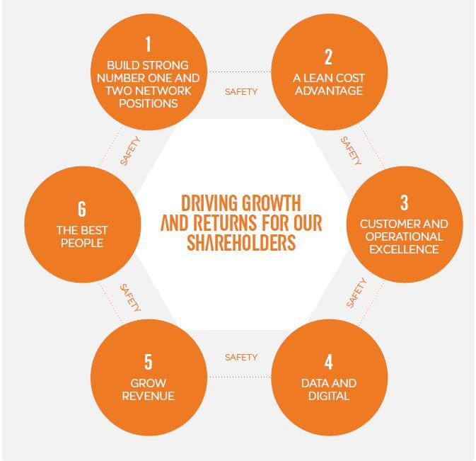

(Source: Easyjet Corporate)

**Figure 4 – Ryanair Facts & Figures**

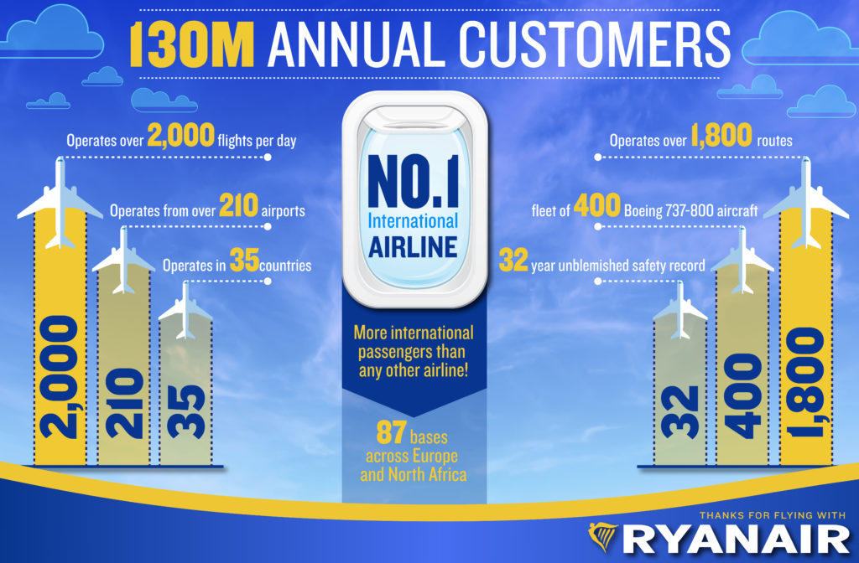

(Source – Ryanair Corporate Website)

**Figure 5 - AIRLINE PUNCTUALITY**

| Ryanair | 88% |
| --- | --- |
| Easyjet | 77% |
| Lufthansa | 84% |
| Air France | Did not publish |
| BA | 78% |
| Aer Lingus | 82% |
| Iberia | 88% |

(Source – Ryanair Corporate Website)

**Figure 6 – Ryanair Daily Operation**

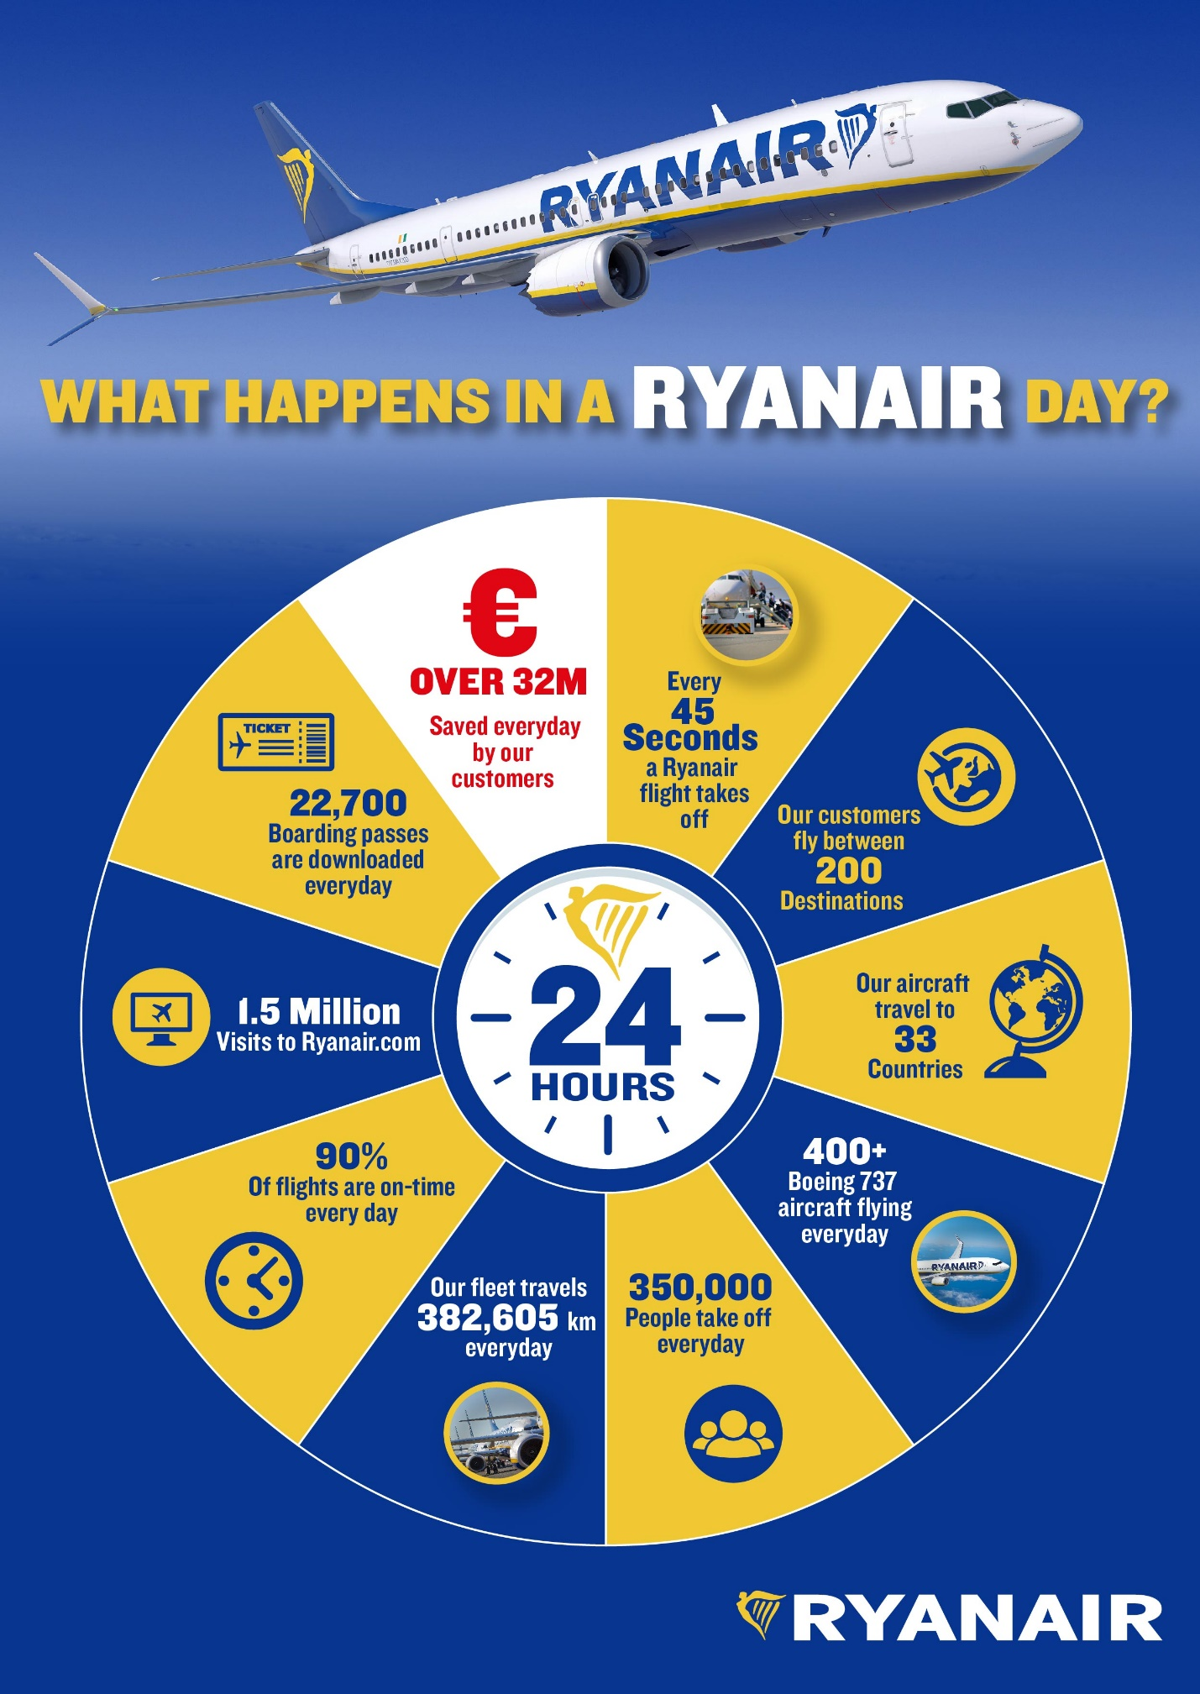

(Source – Ryanair Corporate Website)

**Figure 7 - EasyJet Facts Sheet**

EasyJet’s operation

## Capital

easyJet has a strong capital base, with market capitalization of c.£4 billion and a net cash position of £213 million at 30 September 2016. easyJet’s credit ratings are amongst the strongest in the world for an airline.

## Aircraft

easyJet operates a modern Airbus fleet, using the A320 family of aircraft, and is up-gauging its fleet to 186 seat cabins and the new fuel efficient A320neo aircraft. This provides customer, operating and maintenance benefits to the Group.

## People

easyJet has a dedicated workforce of over 10,000 people, including 2,865 pilots and 6,516 cabin crew members as at 30 September 2016.

# EasyJet values

**Safety:** We never compromise on safety

**Simplicity:** We cut out the things that don’t matter to keep us lean and make it easy

**One team:** Together we'll always find a way

**Integrity:** We stand by our word and do what we say

**Passion:** We have a passion for our customers, our people and the work we do

**Pioneering:** We challenge to find new ways to make travel easy and affordable

(Source – Easyjet Corporate Website)

**Figure 8 –EasyJet Financial Data (Source……)**

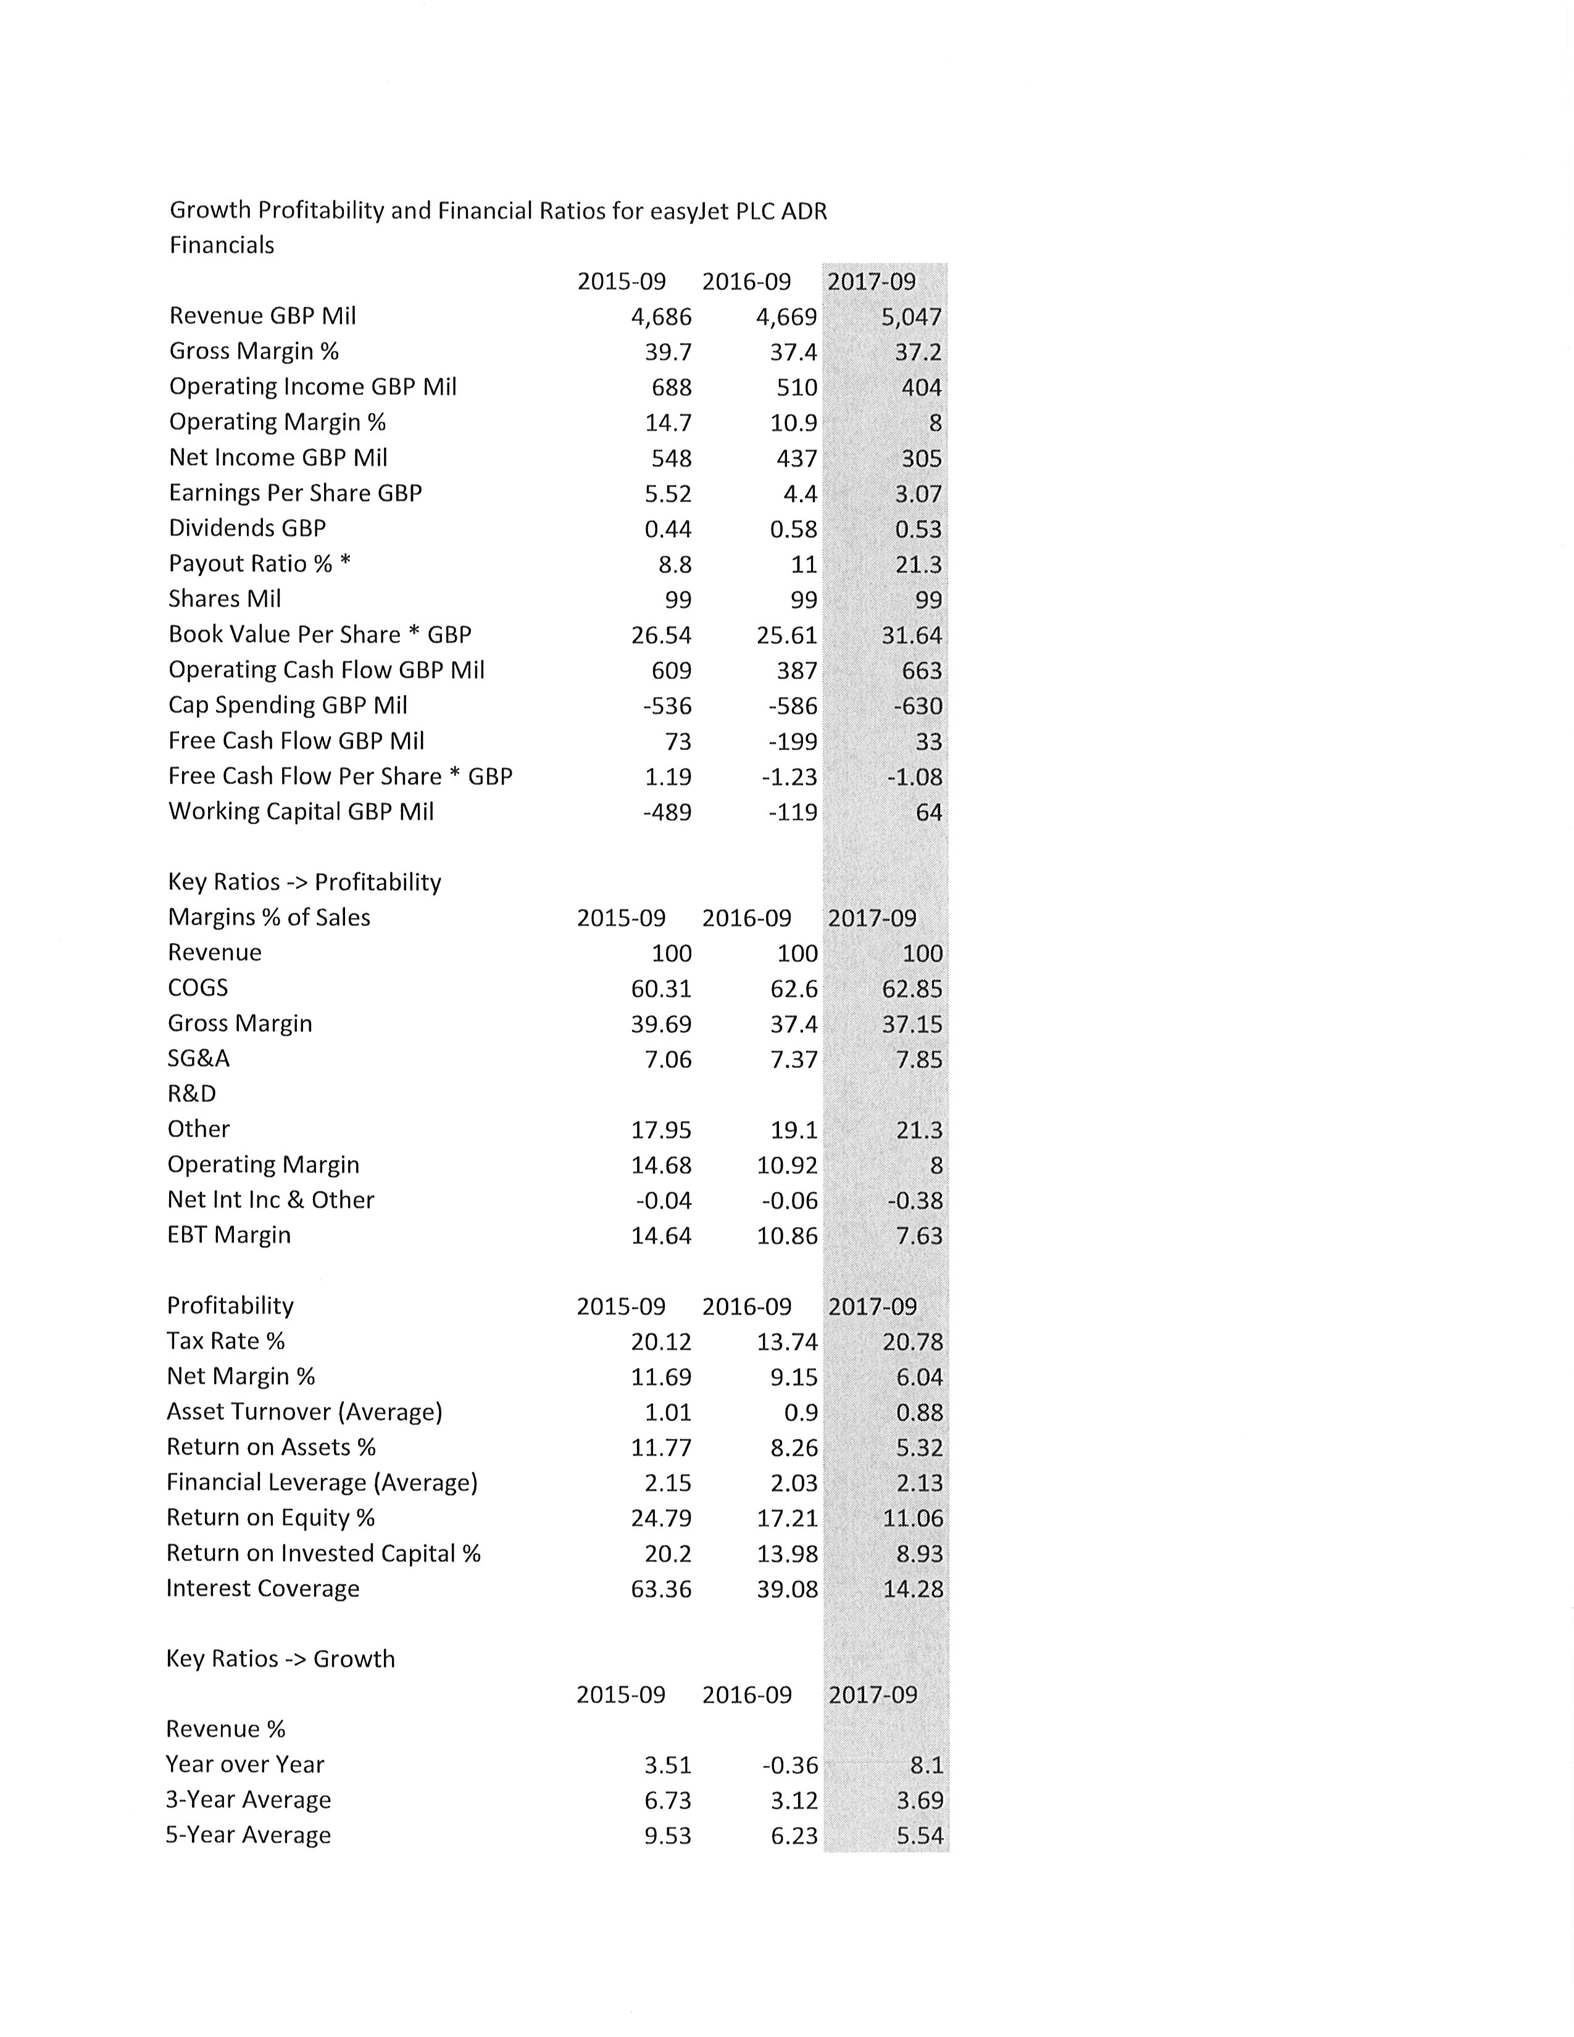

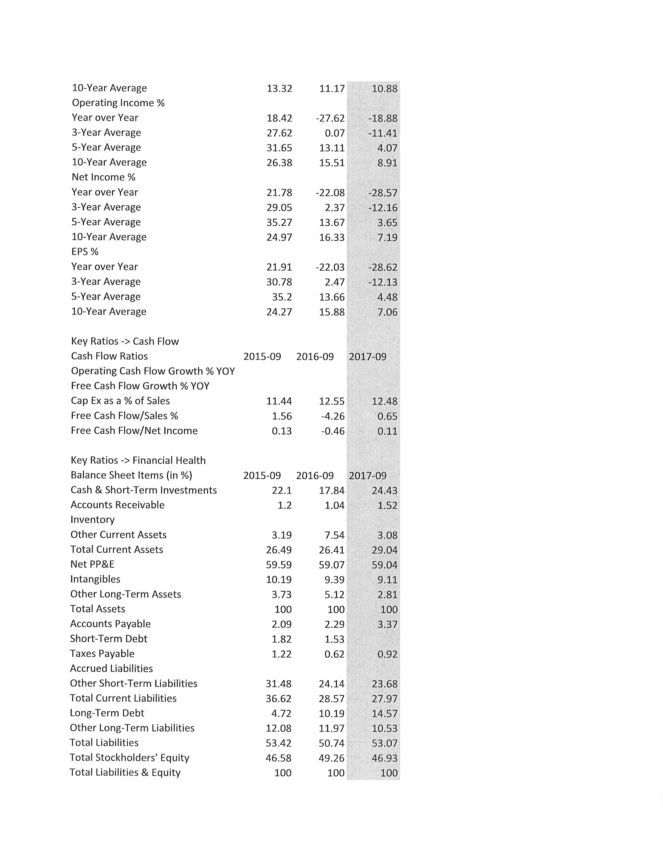

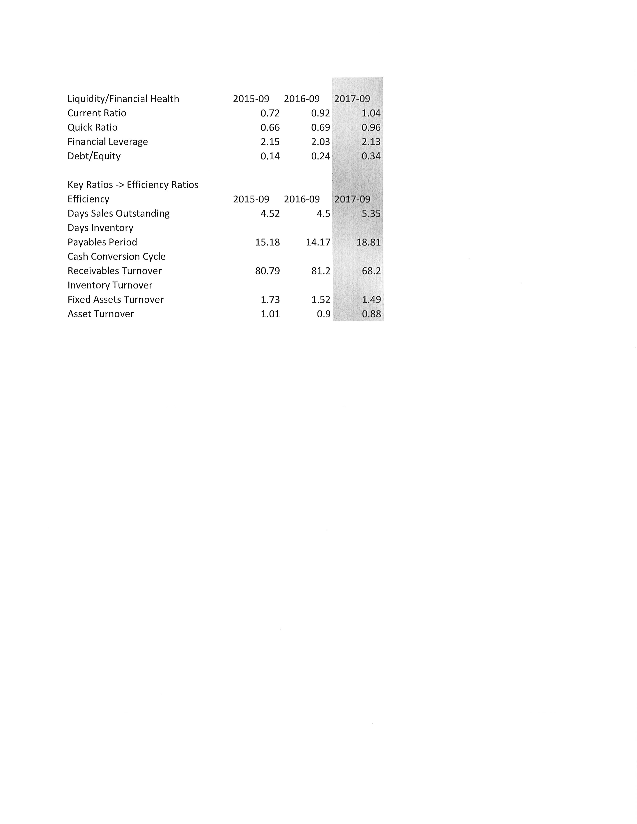

**Figure 9 –Ryanair Financial Data (Source ………)**

