Montemorelos University

Faculty of Business and Legal Sciences

FACTORS THAT CONTRIBUITE TO GREATER CHURCH PERFORMANCE

FOR THE SEVENTH-DAY ADVENTIST CHURCH IN THE

SOUTHEASTERN CONFERENCE

Thesis

presented in partial fulfillment

of the requirements for the degree

Doctorate in Business Administration

by

Donald Paul

February 2020

ABSTRACT

FACTORS THAT CONTRIBUITE TO GREATER CHURCH PERFORMANCE

FOR THE SEVENTH-DAY ADVENTIST CHURCH IN THE

SOUTHEASTERN CONFERENCE

by

Donald Paul

Main advisor: Karla Sarai Basurto Gutiérrez

**CHAPTER I**

**INTRODUCTION**

God expects His church to be specimens of excellence. When His followers exemplify qualities such as discipline, order, and achievement of mission, He is worshipped. His mandate for the church is clear. Until Jesus returns, the role of the church, according to Matthew 28:18-20, is to make disciples. The enterprise of making disciples encompasses the church baptizing and teaching everyone to obey all that Jesus has commanded to us. Consequently, and supreme to the incessant expansion of the kingdom is the finding of new factors that contribute to the performance of the church. In continuous mutability today are societal norms that affect organizational development. According to Logan (1989) and Hunter (1992), researchers must continue to proffer and conduct studies to find out the best practices for effective church performance for each generation. Therefore, this investigation assists in the discovery of factors that contribute to greater church performance.

**Problem Statement**

Leading a church effectively in the twenty-first century has become very intricate and frustrating to many pastors and ministry leaders. Malphurs (1998) declared that 80 to 90% of churches in America are stagnant or in decline. While mainline churches of America are mostly in decline and the Christian churches are mostly stagnant, Penfold (2012) states that so far pastoral education seems to have been ineffective in preparing pastors to reverse the trend. And according to Owen (2012) for education to effectively achieve its stated goals, the curriculum and methods of instruction employed must be regularly assessed. DeGroat (2008) affirms that while the leadership insufficiencies which result in short tenure have been explored for years, most seminary graduates continue to feel wholly unprepared to deal with the realities of pastoral ministry.

There is an ongoing discomfort between church members and their Pastors in the Southeastern conference of Seventh-day Adventists in United States, Florida. The members are becoming very skeptical of their Pastors in the Southeastern Conference of Seventh-day Adventists regarding their Pastor’s effectiveness, which leads quite often to the dismissal of some ministers. The discomfort has just reached a higher level, when for the first time in the executive committee meeting on September the 24th 2017, one pastor was fired, and two others were given three months to find another job. The seriousness of the matter in cumbers both nurture and outreach actions of the church and is a continual cause of member frustration. And it has a negative impact on the performance of the organization. Thus, the church is not performing as it should.

In the 20th century, the focus for organizations was on being effective. Nevertheless, in the 21st century, the requirements have been more than effectiveness; it is required to perform well and to be successful (Scharmer, 2007). Church organizations purposefully transferred their values through their environment and work place. They are expected to take the lead on agenda related to authentic leadership, culture, financial, church performance. For this reason, church spirituality should be considered an important setting that provide quality and positive Christian church.

**Research Question**

The empirical model in which authentical leadership, church spirituality, church culture and financial performance are predictors of church performance within the Southeastern Conference of Seventh-day Adventist Church in Florida, USA?

In Figure 1 the theoretical model which aims to identify possible relationships between the independent variables to the dependent variable is presented.

**Hypothesis**

H0: The empirical model in which authentical leadership, church spirituality, church culture and financial performance are predictors of church performance within the Southeastern Conference of Seventh-day Adventist Church in Florida, USA.

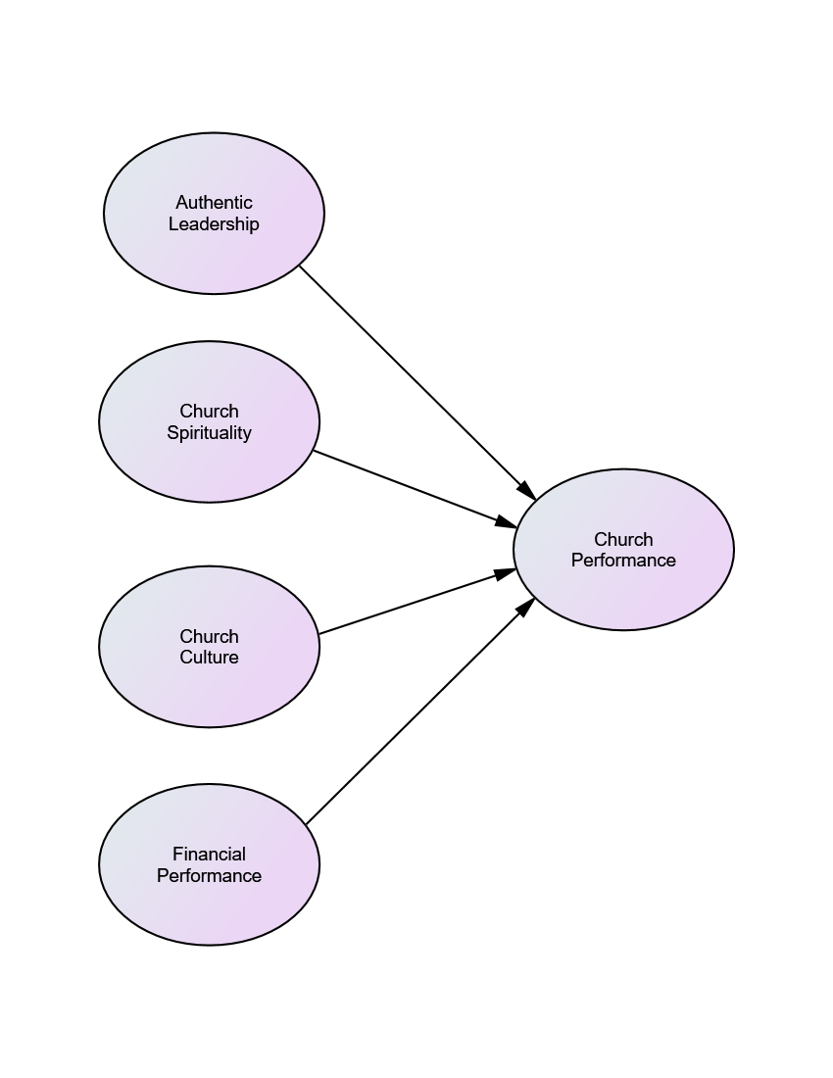

*Figure 1.* Theoretical model for Church performance.

**Research Objectives**

In the following section some research objective is presented.

1. Build questionnaires for measuring authentic leadership, church spirituality, church culture, financial performance and church performance.

2. Evaluate the goodness of the propose model in explaining and evaluating the theoretical relationship between constructs.

3. Assess the variables involved in the study: authentic leadership, church spirituality, church culture, financial performance and church performance.

**Justification**

Leadership and performance skills are important for the church to function and operate properly. Nauss (1972) found that since the 1950s: Increased concern has arisen about the value and effectiveness of clergy performance due to the rate of drop-out or ‘burnout’ among ministers, the unique role demands made on clergy in a complex society, and a heightened sympathy to the nature of effective ministry.

According to Knight (2012), the Seventh-day Adventist church is lacking in the performance of strategy development and church management. He proffered that several factors have been mentioned: (a) the church was resistant to change; (b) the Pastor/Staff person possessed poor people skills; (c) financial resources decreased by lack of good management; (d) lack of time to practice these critical areas of leadership and management of the church.

Purcell (1999) pointed that two overarching factors for a disconnection between the pastor and the congregation are: either the Pastor had poor leadership, or the Pastor had poor change management skills.

McCune and Mills (1968) proposed the need for an improved system of evaluation techniques regarding pastoral performance. The church, in the meantime, is declining. In a study directed by the Review of Graduate Education, Greig (1999) specified that seminaries give their graduate skills to study the bible and theology but not skills to lead the modern church. Hence, seminaries should remain focus on both quality academic education and practical training. Moreover, I believe that further study is needed in this field of church performance in all denominations including the Seventh-day Adventist Church due to numerous issues that we are dealing with. This project seeks to contribute in this regard.

**Limitations**

The study has the following limitations:

1. The research does not attempt to measure church performance of church help. It only examines contextual factors in ministry that are related to church performance.

2. Unable to theoretically test the relationship, together, of all variables in the model.

3. The application of the instrument requires the participation of third parties.

**Delimitations**

This study does not present a representative sample of the whole Church from the various nations where members of the Seventh-day Adventist church live. It provides a random sample from Adventist ministers and lays members within the Southeastern conference of the Seventh-day Adventist in South Florida of the United States of America. Therefore, delimitations in this study included denomination, geographic and administrative region, pastoral position, and lay leader evaluation. This study has a quantitative, descriptive, and explanatory design. Thus, no problem is going to be solved during this time.

**Assumptions**

Below are some scenarios considered in the preparation of this research:

1. It is expected that the participants answered the instruments, both as self-assessment instruments by pastors and as instruments by which followers within a congregation assess their pastor. That process carries with it the assumption that pastors can accurately assess their own pastoral effectiveness and that lay members of their congregations can assess them accurately.

2. This study assumed that pastors and lay leadership would be truthful in their answers.

3. The hypothetical basis of relations between constructs is based on authors who know the subject.

4. The research used as the basis of relations between constructs for this research are pragmatic studies, prepared with scientific consistency and pointedly adequate.

5. It is expected that the research instrument satisfies the objective of this research.

**Philosophical Background**

According to Maxwell (2005), any organizational success or failure is directly linked to a single, crucial factor—leadership. He also mentions that everything rises and falls on leadership. So, in this part of our study, we will display from the Scriptures and from other sources our philosophical view of the constructs of our paper on how the Pastor, as the leader, ought to emulate the life of Jesus, which would promote church performance. I intend here to briefly delineate what it takes to be a Christian leader or what should characterize the life of a Pastor?

On exploring components of church performance, Gavrea, Ilies, and Stegerean (2011) posit that the leadership is a key component that confirms the linking among the success factors of the church.

To be a Christian leader of long tenure and in order to be effective in ministry, one has to cultivate the fear of God. Nowadays, we have great and intellectual preachers and Pastors. They know almost everything in the bible and can teach it impeccably. They know about the great prophecies of the bible; they know all the doctrine of the church, and very admire by the people of God. Yet, when it comes to biblical principles, ethics, standards, disciplines, sacrifice, humility, values, morals, they fall extremely short. They have a different worldview; one that is not biblical. The bible says in Proverbs 9:10 that "The fear of the LORD is the beginning of wisdom, and knowledge of the Holy One is understanding”. The fear of God is a biblical motif that incorporates an attitude of awe and reverence for the holy one. It is the suitable and fundamental response of a person to God. Simply put, to fear God is to have faith in Him, to obey, to love and to serve Him.

It is equivalent to commit suicide when one in ministry with no fear of God. Ignoring the fear of God is recipe for disaster. White (1923) admonished: “Men in responsible positions, whose influence is far-reaching, are to guard well their ways and works, keeping the fear of the Lord ever before them” (p. 360).

In addition to cultivating the fear of God, a Christian leader must have clear understanding of his or her call to be effective and last in ministry. Many Christian leaders have been badly wounded in ministry, some by their own hand and some by the hands of others. And the reason, sometimes, is a distorted sense of their calling into ministry. God calls everyone to the saving knowledge of His Son. But God does not call everyone to be a leader, a pastor, or ministry director. One ought to evaluate his or her call to see where God has called that person to serve. By learning essential beliefs about calling and a means for more tangibly assessing our own calling, we can be stimulated toward ministry accomplishment while being directed away from ministry jeopardy.

Besides cultivating the fear of the Lord and discerning the call of God in one’s life, the Christian leader that wants to sustain long-term effectiveness in ministry should possess the character traits of Jesus. There are many character traits of Jesus, which need to be emulated by all. One can mention for example: Loving, compassionate, Prayerful, self-control, humble, Patience, committed, forgiving, servant, contentment, integrity, etc. For this project, only the following will be considered: Humility, contentment, and integrity.

According to Elwell and Comfort (2001), “*humility* is a condition of lowliness or affliction in which one experiences a loss of power and prestige…Humility is a grateful and spontaneous awareness that life is a gift, and it is manifested as an ungrudging and unhypocritical acknowledgment of absolute dependence upon God.” The Christian leader, therefore, ought to be humble. For, one cannot cultivate the fear of the Lord without being humble. Walvoord and Zuck (1983) posited that, “A person cannot be fearing God (worshiping, trusting, obeying, and serving Him) and be filled with selfish pride at the same time” (p. 952). Humble persons conduct themselves Christ-likely.

The greatest sin according to White (1900) is pride and self-sufficiency. Those who are not humble tend to be prideful and self-sufficient. There is a danger to the effectiveness of Christian leader to finishing well in his ministry when he or she is devoid of humility. In the book Christ’s object lessons, she says this:

The evil that led to Peter’s fall and that shut out the Pharisee from communion with God is proving the ruin of thousands today. There is nothing so offensive to God or so dangerous to the human soul as pride and self-sufficiency. Of all sins it is the most hopeless, the most incurable. (p.154)

Nowadays, pastors must have the same attitude, the same characteristics. Our goal is to exalt Jesus and elevate him as the hope of the world. It means that one must humble himself or herself and self-erase so that people could see the image of Jesus in that individual.

Another trait of Jesus that need to be emulated by all and specially the Christian leader is *contentment*. Contentment is defined as a state of happiness and satisfaction. It is that disposition of mind in which one is, through grace, independent of apparent circumstances, so as not to be moved by greed or envy (James 3:16), anxiety (Matthew 6:24, 34), and discontent (1Corinthians 10:10). A Christian leader that does not learn to be content in all circumstances denies the faith he or she is professing. And this is the epitome of long-term effective pastoral ministry.

Moreover, another trait that needs to be exhibited by all Christians, specially a Pastor, is *integrity*or probity. The bible says that “The integrity of the upright guides them, but the unfaithful are destroyed by their duplicity” (Proverbs 11:3). If a Pastor wants his or her ministry to be effective, he or she must have integrity. The word can be defined as the firm adherence to a code of moral values. A Christian leader preserves lives, not destroy them or self-destroy. When one has integrity, it will be seen in sincerity, truth, pure heart, single eye, honesty, genuineness. Integrity, indeed, is fundamental to true character.

All in all, the role of a Christian leader is of great importance and immeasurable value in the organization and functioning of the Seventh-day Adventist Church. In reality, the success or failure of the church as a whole depends largely on the pastor because of the unique and intimate position he occupies in the church where he is called to fulfill his priestly functions. At all times and in all circumstances, the pastor must reflect the life and teachings of Christ in his ministry and his job. For, Leadership is not about popularity or personality or charm. It is about fulfilling God’s purpose in life.

The Christian leader ought to cultivate the fear of God; without which, he or she will not endure in ministry and would threaten the performance of the church as a whole. The vocation of the pastor must come from God and his ministry must demonstrate at all times that he or she has been accredited by God himself. The Christian leader must exhibit Jesus’s traits in his or her life. And the Christian leader ought to have integrity.